FACULTY PROFILE
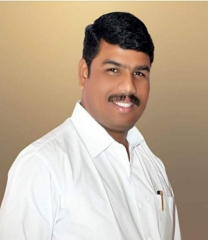
Name : Dr. Navanath Dnyandev Lokhande
Qualification : M. A. B. Ed. NET, Ph. D.
Department : English
Designation : Assistant Professor
Email : ndlokande@gmail.com
Teaching Experience : UG. 15 years PG - 02

ACADEMIC CONTRIBUTIONS

Research Papers : 11

Books Published- 09

Research Area- Translation, Indian Literature, Cultural Studies

Patents-

Research Guidance – Ph.D. Guide (Shivaji University)

Awards/ Fellowship : 1) Dr. Shivajirao Chavan Best Researcher Award
2) Book Of The Year Award
3) State Level Literature Award-2020 - by Shikshak-Sahitya-
Kala- Krida Mandal, Thane

